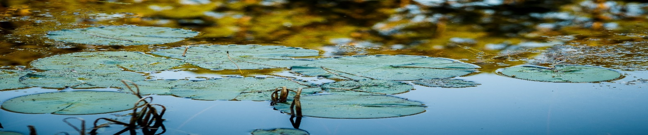

**Texas Watershed Coordinator Roundtable - Agenda**

**October 21, 2020 | 9:30 a.m. – 12:00 p.m.**

**Virtual Roundtable**

9:00 a.m. Registration

9:30 a.m. Welcome, Introductions and Tour

Clint Wolfe & Fouad Jaber, Texas A&M AgriLife

11:30 a.m. Agency Updates, Panel Perspectives and Discussion

Moderator: Lucas Gregory, TWRI

Panelists: Mike Bira, EPA

Faith Hambleton, TCEQ

TJ Helton, TSSWCB

12:00 p.m. Catered networking lunch (or bring your own) [RSVP required]

1:00 p.m. Communicating Watershed Plans to Elected Officials

Mary Luedeker, Texas A&M AgriLife

1:30 p.m. Break

1:45 a.m. North Texas Watershed Updates and Panel Moderator: Lucas Gregory, TWRI

Panelists: Tina Hendon, Tarrant Regional Water District

Galen Roberts, North Texas Municipal Water District

Aaron Hoff, Trinity River Authority

3:15 p.m. Wrap-Up

Nathan Glavy, TWRI

* Upcoming Trainings
* Next Roundtable – January 2020 –TBD

The Texas Watershed Planning Program is managed by the [Texas Water Resources Institute](https://urldefense.proofpoint.com/v2/url?u=http-3A__nrt.tamu.edu_&d=DgMFAg&c=r_tSStIHV2ie60z4DgB-pQ&r=8q4_FjL-g_s-odceBZxvXV6dNDBltB4WLN__xWATliM&m=4HjBCJN2dlfh0l1TLr91qTv4agA10h8Z2ATqQp1-fso&s=0eWJ4TTWGt5NlUYaRDR9XZZ-VAQu4m1AK_0DlNSISz0&e=) and is funded through a Clean Water Act Section 319(h) nonpoint source grant provided by the Texas State Soil and Water Conservation Board and U.S. Environmental Protection Agency.

**9:00 a.m. Event Sign In Online**

**9:30 a.m. Welcome, Introductions and Round Table Overview**

Dr. Lucas Gregory, TWRI

**9:45 a.m. Panel: Engaging Volunteers to Enhance Impact – Experiences From Three Established Programs**

* + - Dr. Lisa Whittlesey – National Junior Master Gardener
    - Michelle Haggerty / Mary Pearl Meuth – Texas Master Naturalists
    - Melissa Felty (Alderson) – Texas Parks and Wildlife Water Specialists

**11:00 a.m. Facilitated Q&A with Volunteer Engagement Speakers**

**11:30 a.m. Federal and State Agency Updates**   
- Continued COVID-19 Implications to Programs and Contracts

**11:55 p.m. Wrap-Up & Program Evaluation**

Nathan Glavy, TWRI

* Next Roundtable – April 2021 –TBD

The Texas Watershed Planning Program is managed by the [Texas Water Resources Institute](https://urldefense.proofpoint.com/v2/url?u=http-3A__nrt.tamu.edu_&d=DgMFAg&c=r_tSStIHV2ie60z4DgB-pQ&r=8q4_FjL-g_s-odceBZxvXV6dNDBltB4WLN__xWATliM&m=4HjBCJN2dlfh0l1TLr91qTv4agA10h8Z2ATqQp1-fso&s=0eWJ4TTWGt5NlUYaRDR9XZZ-VAQu4m1AK_0DlNSISz0&e=) and is funded through a Clean Water Act Section 319(h) nonpoint source grant provided by the Texas State Soil and Water Conservation Board and U.S. Environmental Protection Agency.